**WEATHER PREDICTION USING ML/AI**

A Project-II Report

Submitted in partial fulfillment of requirement of the

Degree of

**BACHELOR OF TECHNOLOGY in COMPUTER SCIENCE & ENGINEERING**

BY

**Sukhsimar Singh Giran**

**EN18CS301273**

Under the Guidance of

**Prof. Priyanka Dhasal**



**Department of Computer Science & Engineering**

**Faculty of Engineering**

**MEDI-CAPS UNIVERSITY, INDORE- 453331**

**May,2022**

**Report Approval**

The project work “**Weather Prediction Using ML/AI”** is hereby approved as a creditable study of an engineering/computer application subject carried out and presented in a manner satisfactory to warrant its acceptance as prerequisite for the Degree for which it has been submitted.

It is to be understood that by this approval the undersigned do not endorse or approved any statement made, opinion expressed, or conclusion drawn there in; but approve the “Project Report” only for the purpose for which it has been submitted.

Internal Examiner

Name:

Designation:

Affiliation:

External Examiner

Name:

Designation

Affiliation

**Declaration**

I/We hereby declare that the project entitled **“Weather Prediction Using ML/AI”** submittedin partial fulfillment for the award of the degree of Bachelor of Technology in Department of Computer Science and Engineering completed under the supervision ofProf. Prasanna Kapse and Prof. Priyanka Dhasal**,** Faculty of Engineering, Medi-Caps University Indore is an authentic work.

Further, I/we declare that the content of this Project work, in full or in parts, have neither been taken from any other source nor have been submitted to any other Institute or University for the award of any degree or diploma.

**Sukhsimar Singh Giran**

**Date -**

**Certificate**

I, **Prof. Priyanka Dhasal** certify that the project entitled **“Weather Prediction Using ML/AI”** submittedin partial fulfillment for the award of the degree of Bachelor of Technology by **Sukhsimar Singh Giran** istherecordcarried out by him/them under my/our guidance and that the work has not formed the basis of award of any other degree elsewhere.

________________________ ________________________

Prof. Priyanka Dhasal Prof. Priyanka Dhasal

Department of Computer Science & Engineering Department of Computer Science & Engineering

Medi-Caps University, Indore Medi-Caps University, Indore

_____________________

Dr. Pramod S. Nair

Head of the Department

Computer Science & Engineering

Medi-Caps University, Indore

**Offer Letter of the Project work-II/Internship**

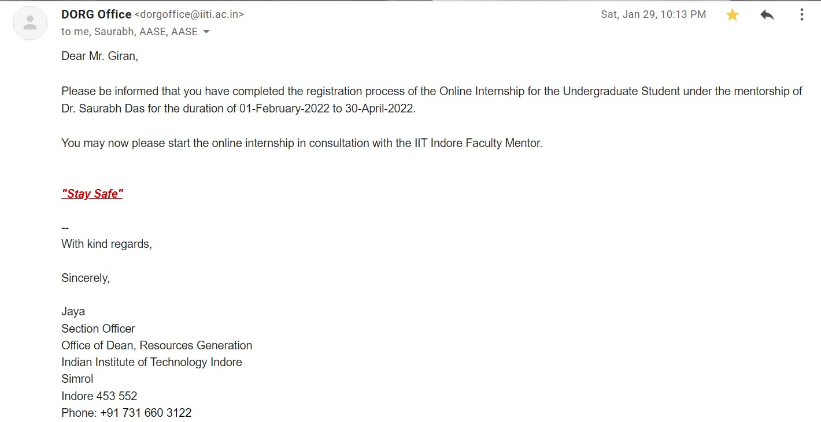

**Completion certificate/Letter**

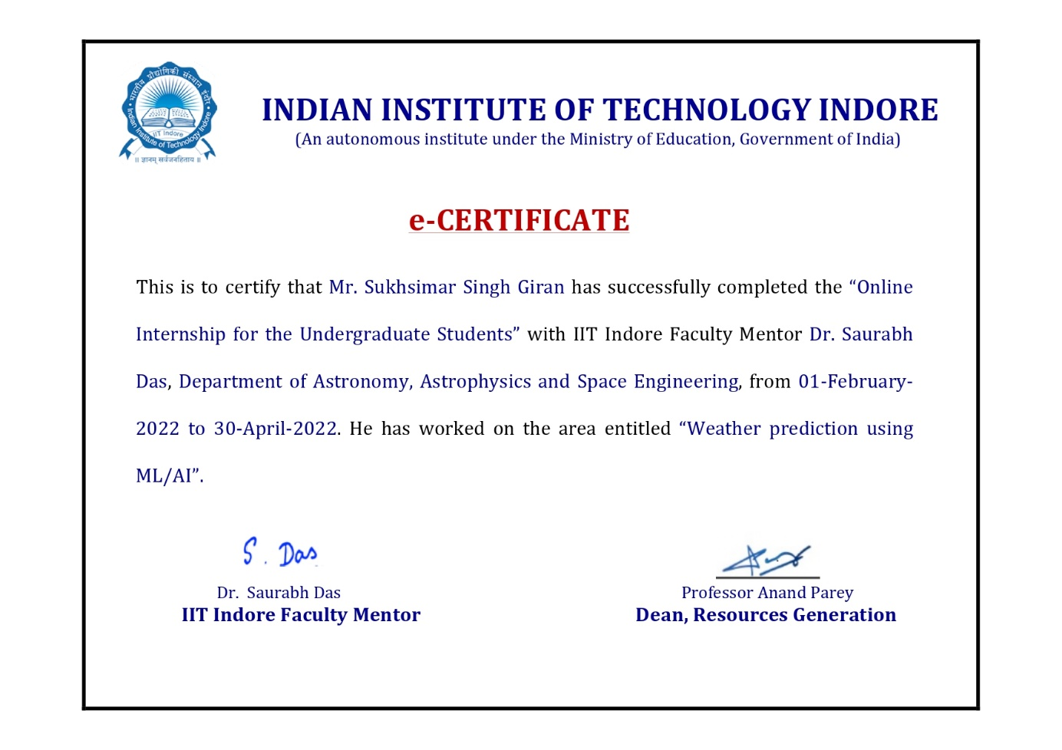

**Acknowledgements**

I would like to express my deepest gratitude to Honorable Chancellor, **Shri R. C. Mittal,** who has provided me with every facility to successfully carry out this project, and my profound indebtedness to **Prof. (Dr.) Dilip K. Patnaik,** Vice Chancellor, Medi-Caps University, whose unfailing support and enthusiasm has always boosted up my morale. I also thank **Prof. (Dr.) D K Panda,** Pro Vice Chancellor, **Dr. Suresh Jain,** DeanFaculty of Engineering, Medi-Caps University, for giving me a chance to work on this project. I would also like to thank my Head of the Department **Dr. Pramod S. Nair** for his continuous encouragement for betterment of the project.

I express my heartfelt gratitude to my **External Guide, Mr. Saurabh Das,** Department of Astronomy, Astrophysics and Space Engineering, Indian Institute of Technology Indore as well as to my Internal Guide **Prof. Priyanka Dhasal**, Department of Computer Science & Engineering, Medi-Caps University, without whose continuous help and support, this project would ever have reached to the completion.

I would also like to thank to my team at Indian Institute of Technology Miss **Hemapriya R**. who extended their kind support and help towards the completion of this project.

It is their help and support, due to which we became able to complete the design and technical report. Without their support this report would not have been possible.

**Sukhsimar Singh Giran**

B.Tech. IV Year

Department of Computer Science & Engineering

Faculty of Engineering

Medi-Caps University, Indore

**Abstract**

Sun holds high impact for space weather phenomena on earth. High speed solar winds can affect earth’s satellites and can also cause geomagnetic storms. Coronal holes are region of dark, low density, open magnetic field in solar corona. These are the regions from where these geomagnetic storms originate. Any information about coronal holes can be useful to predict geomagnetic storms on earth.

Identification of coronal holes is currently a topic of research under various universities and various models for coronal holes detection are being attempted. Here we discuss a CNN based model for CH detection.

**Table of Contents**

|  |  |  |
| --- | --- | --- |
|  |  | **Page No.** |
| Report Approval | ii |
| Declaration | iii |
| Certificate | iv |
| Offer Letter of the Project work-II/Internship | v |
| Completion letter/certificate | vi |
| Acknowledgement | vii |
| Abstract | viii |
| Table of Contents | ix |
| List of figures | xi |
| List of table(s) | xii |
| Abbreviations | xiii |
| **Chapter 1** | **Introduction** |  |
| 1.1 About the Institution | 1 |
| 1.2 Internship Profile | 2 |
| **Chapter 2** | **Coronal Holes** |  |
| 2.1 Introduction | 3 |
| 2.2 Impact of Coronal Hole on Earth | 3 |
| * 1. Initial Method of Coronal Hole Detection | 4 |
| 2.4 Need for Automated Detection | 4 |
| **Chapter 3** | **Coronal hole detection** |  |
| 3.1 General Procedure for CH Detection | 5 |
| 3.2 Image Processing | 5 |
| 3.2.1 Limb-brightening correction | 5 |
| 3.2.2 Inter-instrument intensity transformation | 6 |
| **Chapter 4** | **Technologies Used** |  |
| 4.1 Python | 7 |
| 4.2 Machine Learning | 7 |
| 4.3 Deep Learning | 7 |
| **Chapter 5** | **Image Processing** |  |
| 5.1 Introduction | 8 |
| 5.2 Image Processing Techniques | 8 |
| **Chapter 6** | **Convolutional Neural Networks** |  |
| 6.1 CNN | 10 |
| 6.2 Dataset Used | 13 |
| 6.3 Modules and Libraries Used |  |
| 6.3.1 Keras | 15 |
| 6.3.2 TensorFlow | 16 |
| 6.3.3 Matplotlib | 16 |
| **Chapter 7** | **Case Study : Observational Uncertainty of CH boundaries in automated Detection Schemes** |  |
| 7.1 Abstract | 17 |
| 7.2 Result | 18 |
| **Chapter 8** | **Implementation of CNN architecture** | 20 |
|  | Summary and Conclusion | 25 |
|  | References | 26 |

**List of Figures**

|  |  |  |
| --- | --- | --- |
| **S. No** | **Figure Name** | **Page. No** |
| 1 | Example of coronal holes. | 3 |
| 2 | Irregular shape of Coronal Hole boundaries. | 4 |
| 3 | Comparison of Solar Disk images before and after limb-brightening correction. | 6 |
| 4 | Comparing Intensity Histograms before and after inter-instrument transformation. | 6 |
| 5 | Obtaining a convolved feature from a convolution using kernel. | 11 |
| 6 | Max Pooling: Finding maximum value of a pixel from a portion of the image covered by the kernel. | 12 |
| 7 | Max pooling vs Average pooling. | 13 |
| 8 | Fully Connected (FC) layer. | 13 |
| 9 | CIFAR 10 dataset. | 14 |
| 10 | Differences of CH boundary location due to the choice of various detection schemes. | 19 |
| 11 | Implementation on the CNN architecture: |  |
| Importing the dataset and tenserflow | 20 |
| Download and prepare the CIFAR 10 Dataset | 20 |
| Verify the data | 20 |
| Display first 25 images from training set | 21 |
| Creating a convolutional base | 21 |
| Display model architecture | 22 |
| Add dense layer to the top | 22 |
| Display the complete architecture | 23 |
| Compile and train the model | 23 |
| Evaluate the model | 24 |

**List of Table(s)**

|  |  |  |
| --- | --- | --- |
| **S.No** | **Table Title** | **Page No** |
| 1 | Automated Coronal Hole Detection Schemes widely applied in the community. | 18 |

**Abbreviations**

|  |  |
| --- | --- |
| **Abbreviations** | **Full Forms** |
| CH | Coronal Holes |
| EUV | Extreme Ultraviolet |
| SDO | Solar Dynamics Observatory |
| AIA | Atmospheric Image Assembly |
| STERO | Solar Terrestrial Relations Observatory |
| EUVI | Extreme Ultraviolet Imager |
| ANN | Artificial Neural Network |
| IIT | Indian Institute of Technology |

**Chapter-1**

**Introduction**

* 1. **ABOUT THE INSTITUTION**

Indian Institute of Technology Indore located in Madhya Pradesh, Indore known as IIT Indore is an institute of national importance established by the Government of India in 2009. It is one of the eight new IITs, started by the Ministry of Human Resource Development (India), Government of India. The institution started functioning from 2009-10 in a temporary campus at Institute of Engineering and Technology of Devi Ahilya University under mentorship of IIT Bombay. Shri Arjun Singh, the Union HRD minister, laid the foundation of the permanent campus, spread over an area of around 501.42-acre (2.1 km2), on 17th February 2009 at Simrol, a location on Khandwa Road about 25 km from the city of Indore.

Since, February 2016, IIT Indore has started functioning from its permanent campus. All the Administrative Offices, Material Management Section, Finance and Account Section, The School of Basic Sciences, The School of Humanities and Social Sciences, The School of Engineering, Basic Science Labs and Engineering Labs are all established in this campus. The Central Library is also situated in this campus.

The institute provides instruments/facilities such as Nuclear Magnetic resonance spectrometer, CAD Tools for Very Large Scale Integration (VLSI) Design, Single crystal X-ray diffractometer, Time-correlated single photon counting (TCSPC), Liquid Chromatography Mass Spectrometry Total Internal Reflection Fluorescence Microscopy, Dual ion beam sputtering deposition (DIBSD) system, Spin Coater, Optical Surface Metrology System Profiler,

The Sophisticated Instrumentation Center (SIC) is a national facility hosted at IIT Indore's School of Basic Science. SIC at IIT Indore is equipped with Single Crystal X-ray Diffraction, Nuclear Magnetic Resonance, Mass Spectrometry, Elemental Analysis and Single Molecule Imaging and Spectroscopy.

* 1. **Internship Profile**

Current role is to study and do research on major topics provided by our guide Dr. Saurabh Das and work in collaboration with his PhD. Student Miss. Hemapriya R. in order to create a model which detects corona holes using AI/ML algorithms.

**Chapter-2**

**Coronal Holes**

* 1. **Introduction**

Coronal holes (CH) are regions of open magnetic fields that appear as dark areas in the solar corona due to their low density and temperature compared to the surrounding quiet corona. These dark regions on the Sun were first observed and named during solar eclipses in the 20th century. To date, accurate identification and segmentation of CHs has been a difficult task due to their comparable intensity to neighboring Sun regions.

The detection and mapping CH in solar Extreme Ultraviolet and X-ray images is useful for a variety of scientific and space weather prediction applications. The boundaries of coronal holes are neither smooth nor uniform. Detecting and setting boundaries for CHs is thus difficult and primary factor in the decision to take a machine learning approach for CH detection.

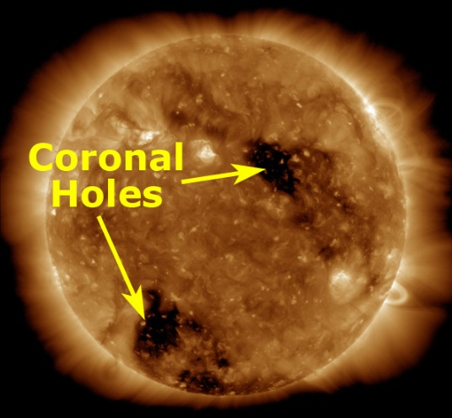

Fig 1 – Example of Coronal Hole

* 1. **Impact of Coronal Holes on Earth**

The Sun holds a high impact for space weather phenomena through the interactions of solar wind streams with Earth's magnetosphere which can result in geomagnetic storms. Solar wind streams can damage satellites and geomagnetic storms may interfere with electrical networks. High speed solar winds can be traced back to low density, dark, open magnetic field region of the corona known as coronal holes. Hence, information about coronal holes can be very useful.

* 1. **Initial Method of Coronal Hole Detected**

The first ever Coronal hole detection was done by Harvey & Recely in the year 2002. Initially, CH segmentation was done by eye based on two-day averages of high intensity images and magnetograms taken by the Kitt peak vacuum telescope. This method adopted the use of magnetograms to separate CHs from other dark coronal features due to the uni-polar nature of CHs and is still popularly used. Henney & Harvey attempted to automate this detection process and, in turn, created the first automated CH segmentation algorithm.

* 1. **Need for Automated Detection**

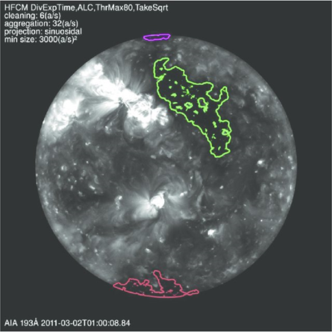As seen in the adjacent figure, the boundaries of coronal holes are neither smooth nor uniform and their boundaries vary in different shape and sharpness so that’s why it is often very difficult for observers to detect any intensity contrast between coronal holes and neighboring regions.

Detecting and setting boundaries for coronal holes is thus difficult and the primary factor in the decision to take a machine learning approach to coronal holes detection. This varying shape and irregular boundaries is one of the main reasons because of which no effective and accurate CH detection model is not yet implemented till now and still a part of research in various organizations around the world. In this report we attempt to make a CNN based model for CH detection and segmentation.

Fig 2 – Irregular Shape of Coronal Hole Boundaries

**Chapter-3**

**Coronal hole detection**

The detection and mapping of CH in solar Extreme Ultraviolet (EUV) and X-ray images is useful for a variety of scientific and space weather prediction applications.

To make accurate and meaningful coronal hole detections, a large amount of solar images are needed which are obtained from various NASA instruments. The data obtained then underwent extensive pre-processing analysis and corrections before being used for detection or mapping purposes.

* 1. **General Procedure for CH Detection**

1. Firstly, the data is collected from NASA instruments like – SDO/AIA, STERO-A/EUVI, STERO-B/EUVI after which these images will undergo pre-processing for analysis and corrections in order to create uniform data across all three instruments.
2. Once these images are processed, then different detection methods are to be applied in order to detect coronal hole regions from other regions in the solar corona.

With the advancement in the field of AI today, new methods are proposed which aims to detect coronal holes directly from the images without any pre-processing. Various image processing techniques and CH Detection algorithms are discussed later.

* 1. **Image Processing**

The data used for this project will be solar disk images, however these images will undergo extensive corrections before being used for coronal holes detection or map creation. Pre-processed images will be stored in a system for later use.

Since coronal holes are often defined as areas of lower intensity, it is imperative that intensity be uniform across the solar disk in order to achieve that limb-brightening correction and inter-instrument intensity corrections will be applied to the images which are discussed ahead.

**3.2.1 Limb-brightening correction**

Through limb-brightening corrections process, images are corrected for center-to-limb intensity variations. Since coronal holes are the areas of lower intensity so it is required that intensity be uniform across the solar disk. When observed through instruments feature observed would appear less bright near limb as compared to disk centre. From the solar limb, distance of line of sight is further and thus result in lower intensity which would affect the Coronal Hole detection. Limb-brightening correction process corrects this.



Fig 3 - Comparison of Solar Disk Images before and after limb-brightening correction

**3.2.2 Inter-instrument intensity transformation**

Similar to the limb brightening correction process, the inter-instrument intensity transformation seeks to correct for intensity differences. Inter-instrument intensity transformation is important because intensity value plays a large role in CH detection and therefore the quality of the detection relies entirely upon the quality and uniformity of the data so it is necessary to pull data from multiple instruments that view the Sun at the same time, yet from different angles. Inter-instrument intensity transformations seeks to correct for the intensity difference observed in images across various instruments.



Fig 4 - Comparison intensity histograms before and after inter-instrument transformation.

**Chapter-4**

**Technologies Used**

* 1. **Python**

Python is an interpreted, object-oriented, high-level programming language with dynamic semantics. Its high-level built in data structures, combined with dynamic typing and dynamic binding, make it very attractive for Rapid Application Development, as well as for use as a scripting or glue language to connect existing components together. Python's simple, easy to learn syntax emphasizes readability and therefore reduces the cost of program maintenance. Python supports modules and packages, which encourages program modularity and code reuse. The Python interpreter and the extensive standard library are available in source or binary form without charge for all major platforms, and can be freely distributed.

* 1. **Machine learning**

Machine Learning is the field of study that gives computers the capability to learn without being explicitly programmed. ML is one of the most exciting technologies that one would have ever come across. As it is evident from the name, it gives the computer that makes it more similar to humans: The ability to learn. Machine learning is actively being used today, perhaps in many more places than one would expect.

* 1. **Deep Learning**

Deep learning is based on the branch of machine learning, which is a subset of artificial intelligence. Since neural networks imitate the human brain and so deep learning will do. In deep learning, nothing is programmed explicitly. Basically, it is a machine learning class that makes use of numerous nonlinear processing units so as to perform feature extraction as well as transformation. The output from each preceding layer is taken as input by each one of the successive layers.

Deep learning models are capable enough to focus on the accurate features themselves by requiring a little guidance from the programmer and are very helpful in solving out the problem of dimensionality. Deep learning algorithms are used, especially when we have a huge no of inputs and outputs. Since deep learning has been evolved by the machine learning, which itself is a subset of artificial intelligence and as the idea behind the artificial intelligence is to mimic the human behavior, so same is "the idea of deep learning to build such algorithm that can mimic the brain". Deep learning is implemented with the help of Neural Networks, and the idea behind the motivation of Neural Network is the biological neurons, which is nothing but a brain cell.

**Chapter-5**

**Image Processing**

**5.1 Introduction**

Image processing is a method to perform some operations on an image, in order to get an enhanced image or to extract some useful information from it. It is a type of signal processing in which input is an image and output may be image or characteristics/features associated with that image. The image processing system usually treats all images as 2D signals when applying certain predetermined signal processing methods.

Image processing basically includes the following three steps:

* Importing the image via image acquisition tools
* Analyzing and manipulating the image
* Output in which result can be altered image or report that is based on image analysis.
  1. **Image Processing Techniques**
* Artificial Neural Network –

Artificial Neural Network is a computational model that consist of several processing elements that receive inputs and deliver outputs based on their pre define activation function.

ANNs most commonly used for a wide variety of problems, are based on a supervised procedure and comprise three layers: input, hidden, and output.

* Convolutional Neural Network -

In deep learning, a convolutional neural network (CNN/ConvNet) is a class of deep neural networks, most commonly applied to analyze visual imagery. Now when we think of a neural network we think about matrix multiplications but that is not the case with ConvNet.

It uses a special technique called Convolution. Now in mathematics convolution is a mathematical operation on two functions that produces a third function that expresses how the shape of one is modified by the other.

* Decision tree-

It is also a supervised machine learning algorithm, which at its core is the tree data structure only, using a couple of if/else statements on the features selected.

Decision trees are based on a hierarchical rule-based method and permits the acceptance and rejection of class labels at each intermediary stage/level.

In this project, for the implementation of Coronal Hole detection we have used image processing using the **Convolutional Neural Network (CNN)** to detect the Coronal Holes from the image of solar disks.

The Convolutional Neural Network is discussed in brief later in this report.

**Chapter-6**

**Convolutional Neural Network**

**6.1 CNN -**

Convolutional Neural Network, commonly referred to as CNN or ConvNet. It's a deep, feed-forward artificial neural network. he models are called "feed-forward" because information flows right through the model. There are no feedback connections in which outputs of the model are fed back into itself.

Convolutional neural networks have been one of the most influential innovations in the field of computer vision. They have performed a lot better than traditional computer vision and have produced state-of-the-art results. These neural networks have proven to be successful in many different real-life case studies and applications, like:

* Image classification, object detection, segmentation, face recognition
* Self driving cars that leverage CNN based vision systems
* Classification of crystal structure using a convolutional neural network

The architecture performs a better fitting to the image dataset due to the reduction in the number of parameters involved and reusability of weights. In other words, the network can be trained to understand the sophistication of the image better. The role of the ConvNet is to reduce the images into a form which is easier to process, without losing features which are critical for getting a good prediction. This is important when we are to design an architecture which is not only good at learning features but also is scalable to massive datasets.

The element involved in carrying out the convolution operation in the first part of a Convolutional Layer is called the Kernel/Filter, K.

*Convolutional Layer - Kernel*

The objective of the Convolution Operation is to extract the high-level features such as edges, from the input image. ConvNets need not be limited to only one Convolutional Layer. Conventionally, the first ConvLayer is responsible for capturing the Low-Level features such as edges, color, gradient orientation, etc. With added layers, the architecture adapts to the High-Level features as well, giving us a network which has the wholesome understanding of images in the dataset, similar to how we would.

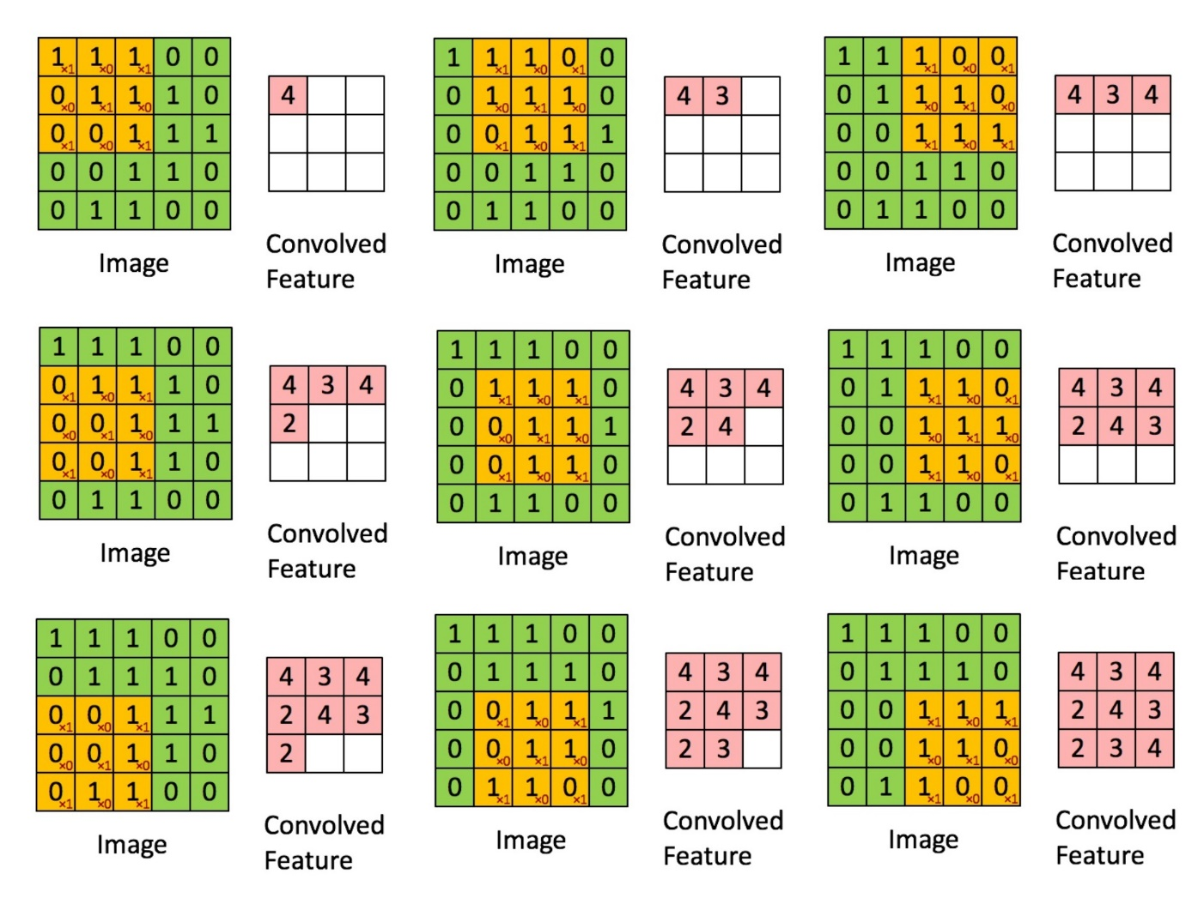

Fig 5 - Obtaining a Convolved feature from a convolution using fillers.

There are two types of results to the operation — one in which the convolved feature is reduced in dimensionality as compared to the input, and the other in which the dimensionality is either increased or remains the same. This is done by applying Valid Padding in case of the former, or Same Padding in the case of the latter.

*Pooling Layer –*

Similar to the Convolutional Layer, the Pooling layer is responsible for reducing the spatial size of the Convolved Feature. This is to decrease the computational power required to process the data through dimensionality reduction. Furthermore, it is useful for extracting dominant features which are rotational and positional invariant, thus maintaining the process of effectively training of the model.

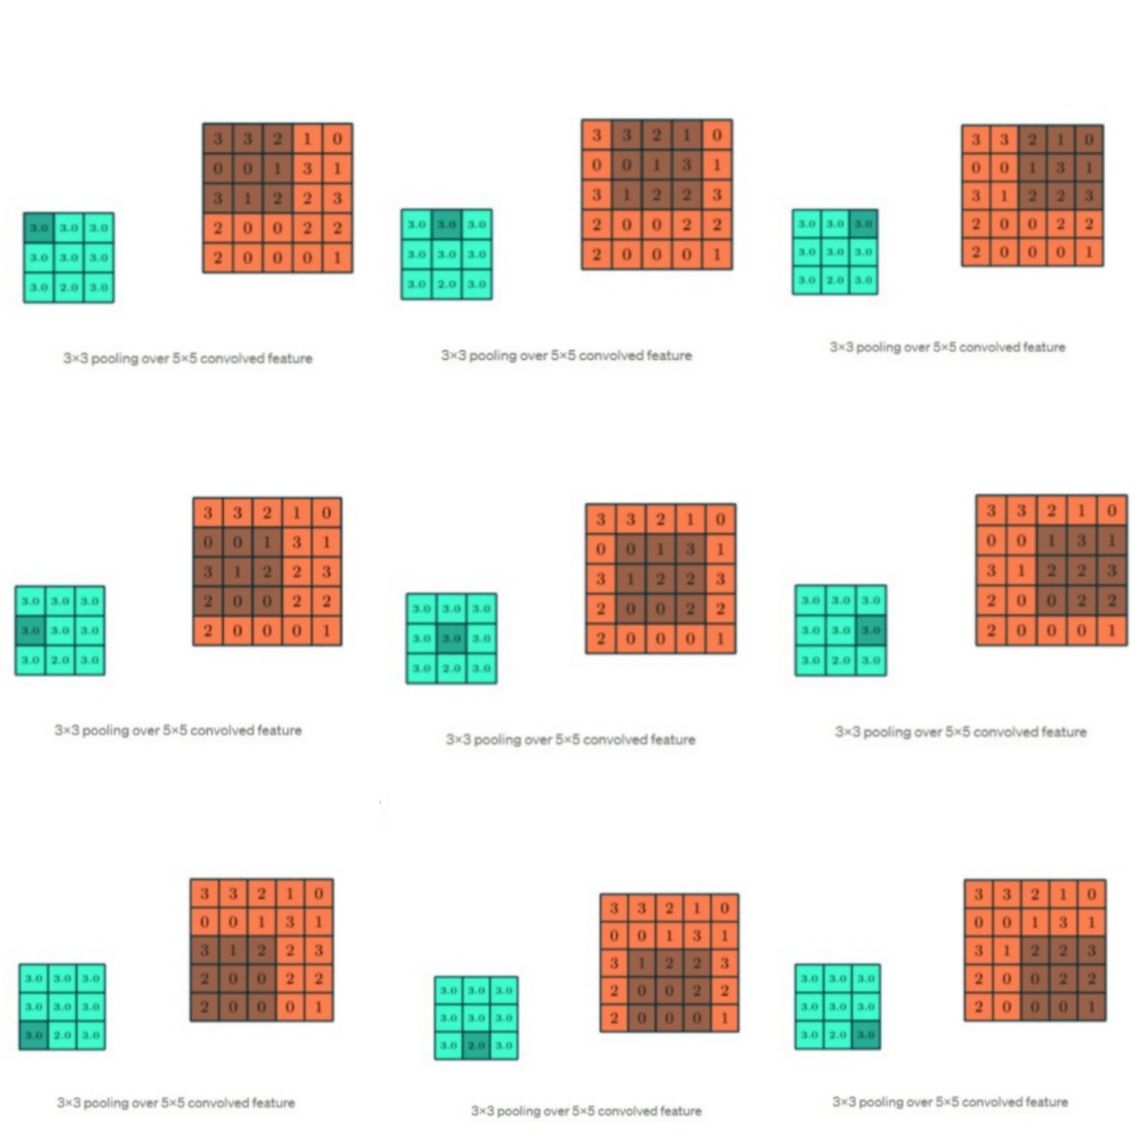

Fig 6 – Max Pooling: Finding the maximum value of a pixel from a portion of the image covered by the kernel.

***There are two types of Pooling***: Max Pooling and Average Pooling. Max Pooling returns the maximum value from the portion of the image covered by the Kernel. On the other hand, Average Pooling returns the average of all the values from the portion of the image covered by the Kernel.

Max Pooling also performs as a Noise Suppressant. It discards the noisy activations altogether and also performs de-noising along with dimensionality reduction. On the other hand, Average Pooling simply performs dimensionality reduction as a noise suppressing mechanism. Hence, we can say that Max Pooling performs a lot better than Average Pooling.

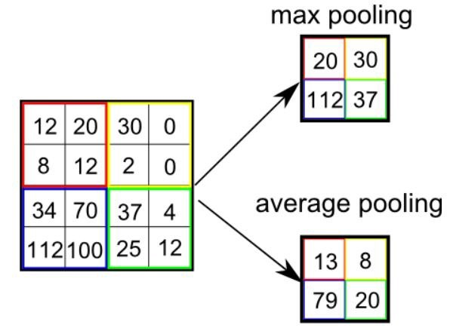Fig 7 - Max Pooling vs Average Pooling

*Classification — Fully Connected Layer (FC Layer)*

Adding a Fully-Connected layer is a (usually) cheap way of learning non-linear combinations of the high-level features as represented by the output of the convolutional layer. The Fully-Connected layer is learning a possibly non-linear function in that space.

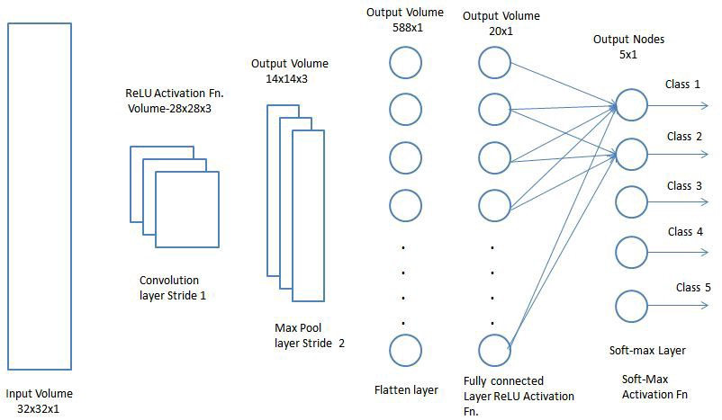

Fig 8 – Fully Connected Layer

**6.2 Data set used**

The dataset for CH detection is solar images obtained by NASA instruments. This dataset is generally of very large size and not easily available, so currently while creating our CNN architecture we have used a sample dataset named CIFAR10.

**CIFAR 10**

The CIFAR 10 (Canadian Institute for Advanced Research) will be harder to classify and will come with new barriers which we will need to overcome. It is a collection of the image which is commonly used to train machine learning and computer vision algorithms. The CIFAR 10 dataset contains 50000 training images and 10000 validation images such that the images can be classified between 10 different classes.

The CIFAR-10 dataset consists of 60000 thirty by thirty color images in 10 classes means 6000 images per class. This dataset is divided into one test batch and five training batches. Every batch contains 10000 images. In the test batch, there are 1000 images which are randomly selected from each class. The training batch contains remaining images in random order. Some of the training batches may contain more images from one class than another.

The classes will be completely mutually exclusive. There will be no overlapping between automobiles and trucks. Automobiles include things which are similar to sedans and SUVs. Trucks class includes only big trucks, and it neither includes pickup trucks. As opposed to the MNIST dataset, the objects within these classes are much more complex in nature and extremely varied. If we are looked through the CIFAR dataset, we realize that there is not just one type of bird or cat. The bird and cat class contains many different types of birds and cat varying in size, color, magnification, different angles, and different poses.

With the endless dataset, although there are many ways in which we can write the number one and number two. It just was not as varied, and on the top of that, the endless dataset is a gray scalar. The CIFAR dataset contains a larger 32 by 32 color images, and each image is with three different color channels.

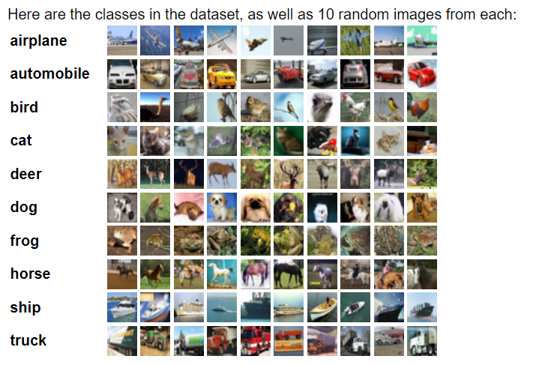

Fig 9 – CIFAR 10 Dataset

**6.3 Modules and Libraries used**

**6.3.1Keras**

Keras is a deep learning API written in Python, running on top of the machine learning platform TensorFlow. It was developed with a focus on enabling fast experimentation. Being able to go from idea to result as fast as possible is key to doing good research.

Keras is

* Simple -- but not simplistic. Keras reduces developer cognitive load to free you to focus on the parts of the problem that really matter.
* Flexible -- Keras adopts the principle of progressive disclosure of complexity: simple workflows should be quick and easy, while arbitrarily advanced workflows should be possible via a clear path that builds upon what you've already learned.
* Powerful -- Keras provides industry-strength performance and scalability: it is used by organizations and companies including NASA, YouTube.

**Keras Models**

Keras model represents the actual neural network model. Keras provides a two mode to create the model, simple and easy to use Sequential API as well as more flexible and advanced Functional API. Let us learn now to create model using both Sequential and Functional API in this chapter.

**Keras Sequential**

The core idea of Sequential API is simply arranging the Keras layers in a sequential order and so, it is called Sequential API. Most of the ANN also has layers in sequential order and the data flows from one layer to another layer in the given order until the data finally reaches the output layer.

**Keras Functional API**

The Keras functional API is a way to create models that are more flexible than the tf.keras.Sequential API. The functional API can handle models with non-linear topology, shared layers, and even multiple inputs or outputs.

The main idea is that a deep learning model is usually a directed acyclic graph (DAG) of layers. So the functional API is a way to build graphs of layers.

**Keras layers**

Keras encompasses a wide range of predefined layers as well as it permits you to create your own layer. It acts as a major building block while building a Keras model. In Keras, whenever each layer receives an input, it performs some computations that result in transformed information. The output of one layer is fed as input to the other layer. Keras Core layer comprises of a dense layer, which is a dot product plus bias, an activation layer that transfers a function or neuron shape, a dropout layer, which randomly at each training update, sets a fraction of input unit to zero so as to avoid the issue of overfitting, a lambda layer that wraps an arbitrary expression just like an object of a Layer, etc.

The Keras convolution layer utilizes filters for the creation of a feature map, runs from 1D to 3D. It includes most of the common invariants, for example, cropping and transposed convolution layer for each dimension. The 2D convolution is used for image recognition as it is inspired by the visual cortex.

**6.3.2TensorFlow**

TensorFlow tutorial is designed for both beginners and professionals. Our tutorial provides all the basic and advanced concept of machine learning and deep learning concept such as deep neural network, image processing and sentiment analysis. TensorFlow is one of the famous deep learning framework, developed by Google Team. It is a free and open source software library and designed in Python programming language, this tutorial is designed in such a way that we can easily implement deep learning project on TensorFlow in an easy and efficient way

**6.3.3Matplotlib**

Human minds are more adaptive for the visual representation of data rather than textual data. We can easily understand things when they are visualized. It is better to represent the data through the graph where we can analyse the data more efficiently and make the specific decision according to data analysis. Before learning the matplotlib, we need to understand data visualization and why data visualization is important.

**Chapter-7**

**Case Study : Observational Uncertainty of CH boundaries in automated Detection Schemes**

**7.1 Abstract**

Coronal holes are the observational manifestation of the solar magnetic field open to the heliosphere and are of pivotal importance for our understanding of the origin and acceleration of the solar wind. Observations from space missions such as the Solar Dynamics Observatory now allow us to study coronal holes in unprecedented detail. Instrumental effects and other factors, however, pose a challenge to automatically detect coronal holes in solar imagery. The science community addresses these challenges with different detection schemes. Until now, little attention has been paid to assessing the disagreement between these schemes. In this COSPAR ISWAT initiative, we present a comparison of nine automated detection schemes widely applied in solar and space science. We study, specifically, a prevailing coronal hole observed by the Atmospheric Imaging Assembly instrument on 2018 May 30. Our results indicate that the choice of detection scheme has a significant effect on the location of the coronal hole boundary. Physical properties in coronal holes such as the area, mean intensity, and mean magnetic field strength vary by a factor of up to 4.5 between the maximum and minimum values. We conclude that our findings are relevant for coronal hole research from the past decade, and are therefore of interest to the solar and space research community.

*Case Study:*

To quantify the uncertainty of coronal hole boundaries in automated detection schemes, we study an example low latitude coronal hole on 2018 May 30. As shown in Figure 10,the hole is located near the disk center, southward of the active region AR 12712. Persistent for several solar rotations, it was first observed around 2017 November 24. Initially, the hole was connected to a southern polar coronal hole with negative polarity as expected for solar cycle.

The Case Study compared nine automated detection schemes widely applied in coronal hole research. Table 1 lists these schemes along with their short name, institution, reference, input wave bands, and online platform. Although each scheme aims to classify each pixel in a solar coronal image as a coronal hole or background, the methods to do so are diverse. A common strategy is an intensity-based thresholding due to the high contrast of coronal holes compared to the rest of the coronal plasma.

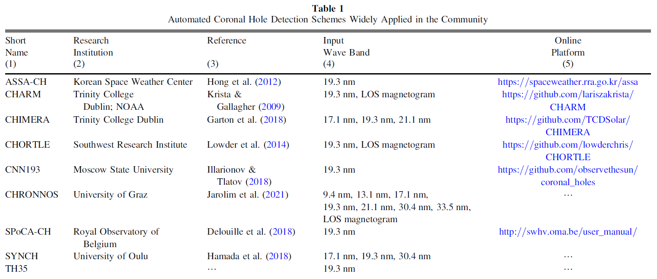

We study the physical properties inside the detected coronal holes using measures described in Ko et al. (2014). For the EUV data we focus on the mean intensity in the AIA 19.3 nm wave band (I193), which is the average intensity of all pixels inside the CH boundary given in data numbers (DNs) per second.

**7.2 Results**

In Figure 2, we present the coronal hole boundaries for the nine detection schemes on 2018 May 30, an example that is challenging for automated schemes. An initial visual assessment shows that the different schemes produce significantly different outcomes. These differences are minimal around the dark regions denoting the center of the coronal hole, and most prominent farthest from the center. Smaller differences also arise inside the coronal hole boundaries, most likely due to ephemeral regions inside the coronal hole (see, for instance, Wang 2020). While all methods are capable of detecting the coronal hole, its size and form vary considerably. And these differences are not only restricted to its shape; the physical properties of the coronal hole also show large differences.

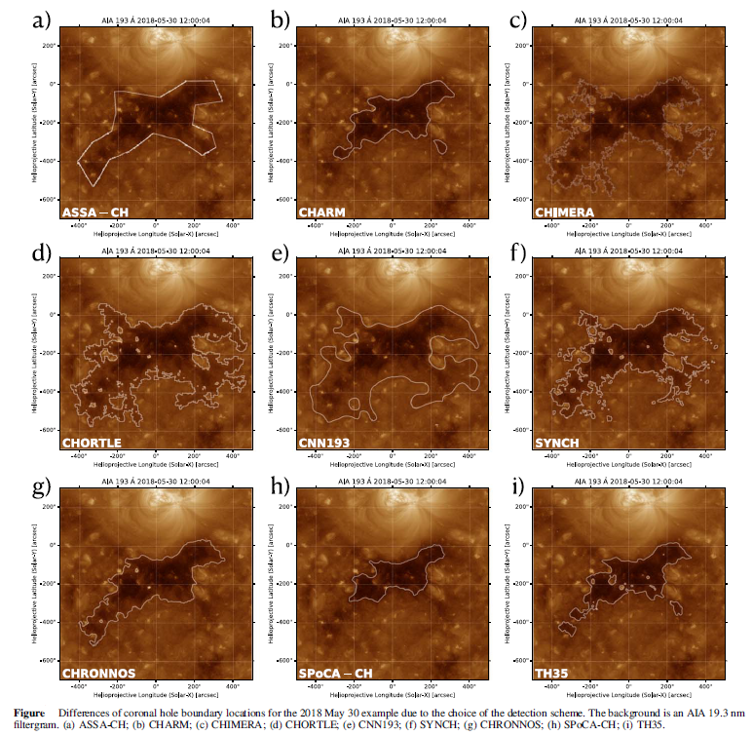  
Fig 10 – Differences of CH boundary locations due to choice of various detection scheme.

**Chapter-8**

**Implementation of CNN architecture**

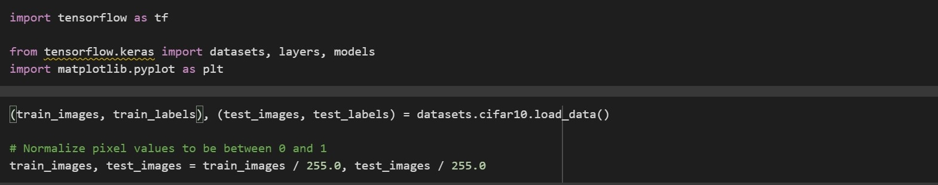Importing the data set and tensorflow

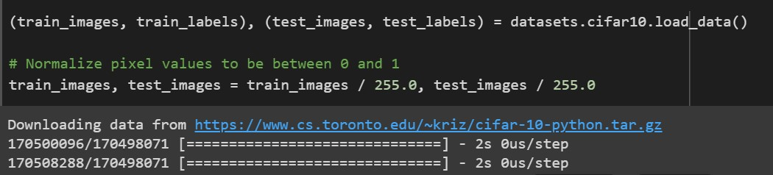Download and prepare the CIFAR10 dataset

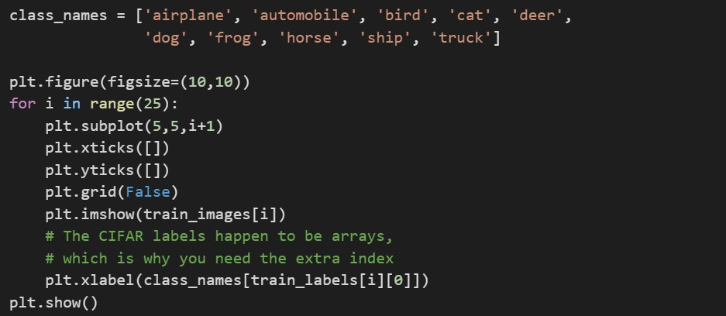Verify the data

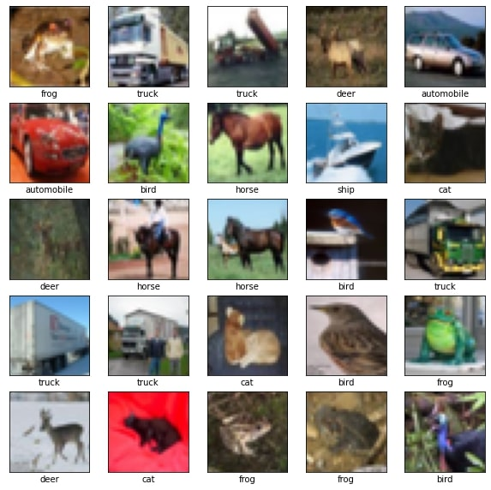Displaying first 25 images from the training set and display the class name below each image.

Creating the convolutional base

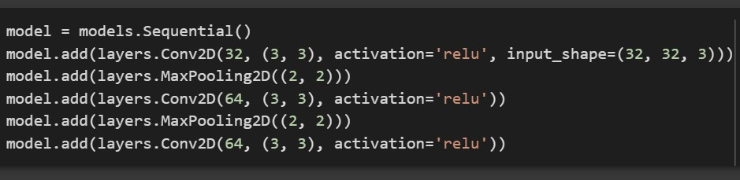

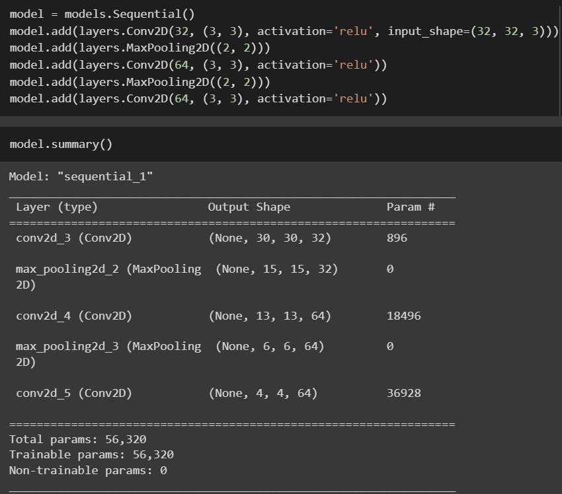Display the architecture of model

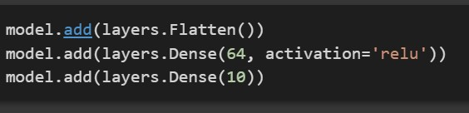Add dense layers on the top

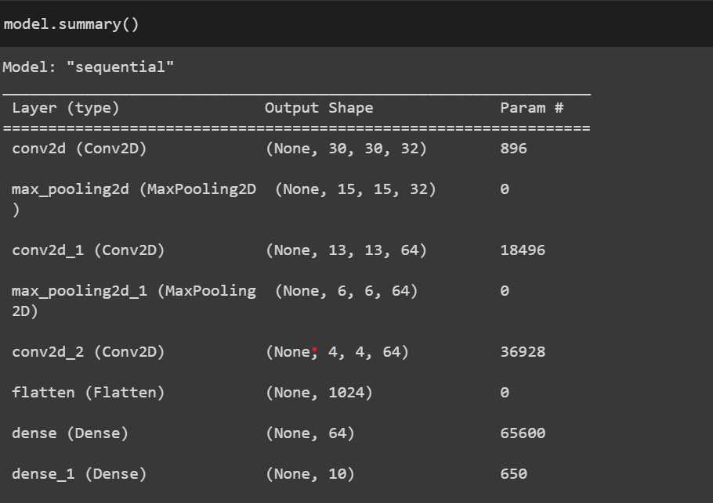The complete architecture of model

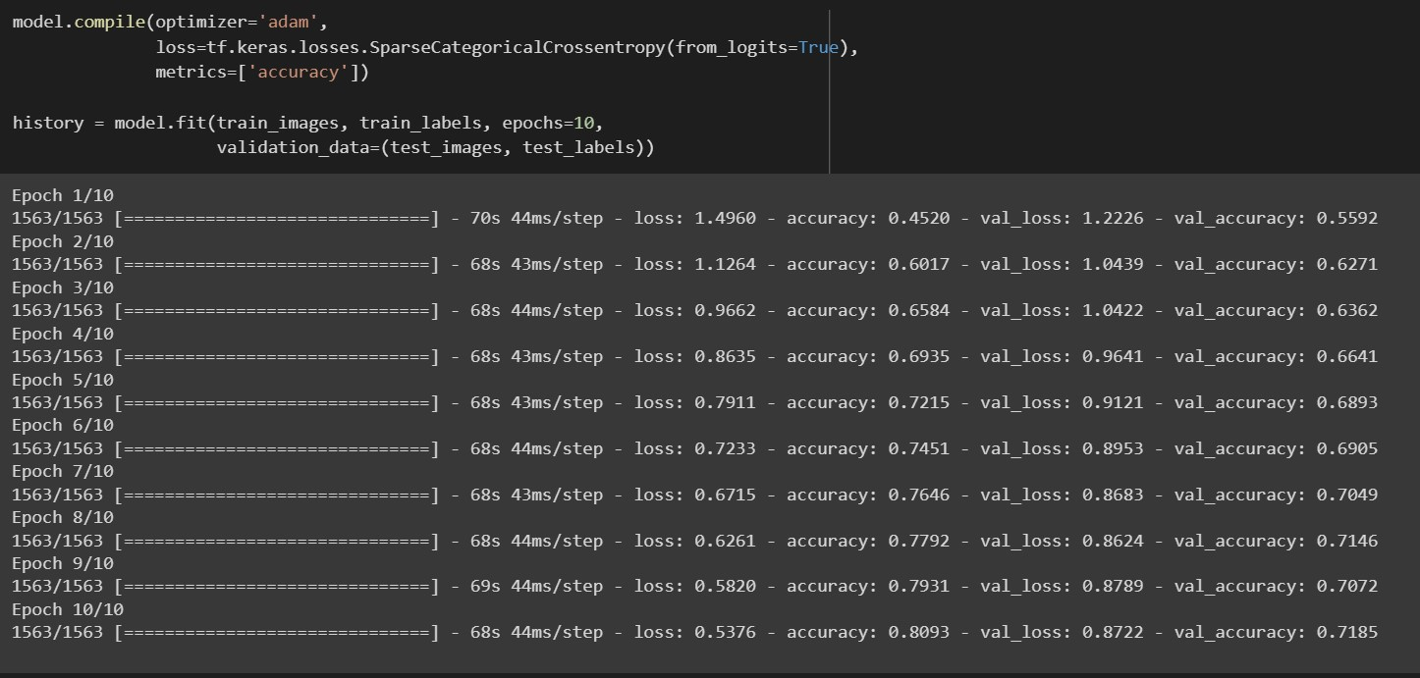Compile and train the model

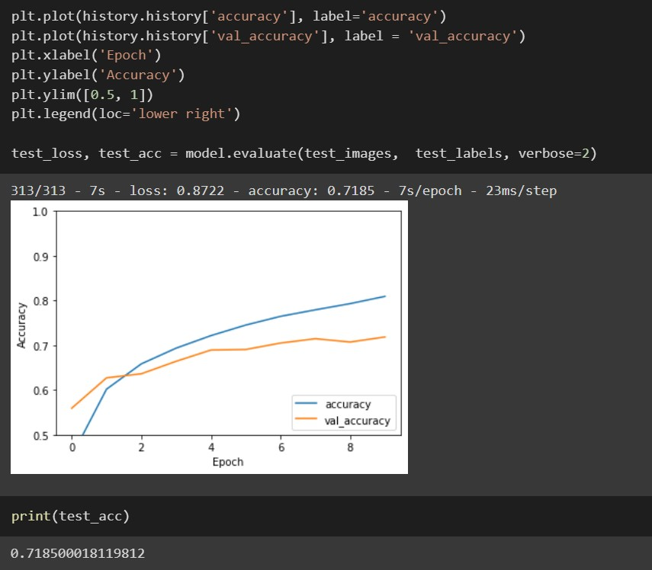Evaluate the model



**Summary and Conclusion**

Machine learning is a type of artificial intelligence which allows software applications to become more accurate at predicting outcomes therefore it is widely used in areas of research worldwide. Using ML technologies help the users to perform task more efficiently and easily therefore reducing the chances of error. Since Sun is far away from earth observing it was very difficult and error prone. Thanks to image recognition techniques this problem is now solved and has extended the area of weather exploring to new limits. Using to ML techniques the time taken for solar observation is highly reduced therefor solar storms or other solar impacts on earth can be predicted much quickly.

Coronal Holes are currently a challenging topic of research among various institutes worldwide, due to their varying shapes and sizes. Various Coronal Hole detection schemes worldwide has created a new challenge as all the schemes show slightly different CH boundaries. A perfect detection algorithm is yet to be implemented.

As a result of this internship, now I am aware of various solar concepts as well as I have learned to read and understand research articles. It also developed a new interest in me and increased my knowledge base. The overall duration of internship program was a great learning time and it also gave me the experience of working in the industry.

**References**

* Coronal Hole Detection using Machine Learning Techniques (Tamar Ervin, Jacob Bortnik, Copper Downs - 2021)
* The Observationsl Uncertanity of Coronal Hole Boundaries in Automation Schemes (<https://doi.org/10.3847/1538-4357/abf2c8>)
* Automated coronal hole identification via multi-thermal intensity segmentation (<https://doi.org/10.1051/swsc/2017039>)
* Keras API - <https://keras.io/api/>
* <https://www.analyticsvidhya.com/blog/2021/06/image-classification-using-convolutional-neural-network-with-python/>
* Python Documentation - <https://docs.python.org/>
* <https://suntoday.lmsal.com/suntoday/>
* <https://www.datacamp.com/community/tutorials/convolutional-neural-networks-python>